Day-10
Task-1
What is spring JPA
Spring Data JPA is a Spring module that simplifies database operations by providing an abstraction over JPA (Java Persistence API). It reduces the amount of boilerplate code by automatically implementing common CRUD (Create, Read, Update, Delete) operations.
Task-2
What are the key features of Spring data JPA?
Spring Data JPA simplifies database access by providing repository interfaces, built-in CRUD operations, automatic query generation, pagination, sorting, transaction management, and seamless integration with JPA providers like Hibernate. It reduces boilerplate code and speeds up application development.
Task-3
What are core components of Spring data JPA?
The core components of Spring Data JPA are Entity, Repository, JPA, Hibernate, EntityManager, DataSource, and Repository interfaces like JpaRepository. Together, they simplify database access by providing object-relational mapping and built-in CRUD operations.
Task 4:
Now create a spring application using initializer
Create a customer entity with id and account type

package com.example.customer.repository;
import com.example.customer.entity.Customer;
import org.springframework.data.jpa.repository.JpaRepository;
public interface CustomerRepository extends JpaRepository<Customer, Integer> {
}

package com.example.customer.entity;
import jakarta.persistence.Entity;
import jakarta.persistence.GeneratedValue;
import jakarta.persistence.GenerationType;
import jakarta.persistence.Id;
@Entity
public class Customer {
@Id
@GeneratedValue(strategy = GenerationType.IDENTITY)
private int id;
private String accounttype;
// Default Constructor
public Customer() {
}
// Parameterized Constructor
public Customer(String accounttype) {
this.accounttype = accounttype;
}
// Getters and Setters
public int getId() {
return id;
}
public void setId(int id) {
this.id = id;
}
public String getAccounttype() {
return accounttype;
}
public void SetAccounttype(String accounttype) {
this.accounttype = accounttype;
}
}

package com.example.customer.entity;
import jakarta.persistence.Entity;
import jakarta.persistence.GeneratedValue;
import jakarta.persistence.GenerationType;
import jakarta.persistence.Id;
@Entity
public class Customer {
@Id
@GeneratedValue(strategy = GenerationType.IDENTITY)
private int id;
private String accounttype;
// Default Constructor
public Customer() {
}
// Parameterized Constructor
public Customer(String accounttype) {
this.accounttype = accounttype;
}
// Getters and Setters
public int getId() {
return id;
}
public void setId(int id) {
this.id = id;
}
public String getAccounttype() {
return accounttype;
}
public void SetAccounttype(String accounttype) {
this.accounttype = accounttype;
}
}

spring.application.name=customer
# H2 Database
spring.datasource.url=jdbc:h2:mem:customerdb
spring.datasource.driverClassName=org.h2.Driver
spring.datasource.username=sa
spring.datasource.password=
# JPA
spring.jpa.hibernate.ddl-auto=update
spring.jpa.show-sql=true
spring.jpa.properties.hibernate.format_sql=true
# H2 Console
spring.h2.console.enabled=true
spring.h2.console.path=/h2-console

<?xml version="1.0" encoding="UTF-8"?>
<project xmlns="http://maven.apache.org/POM/4.0.0"
xmlns:xsi="http://www.w3.org/2001/XMLSchema-instance"
xsi:schemaLocation="https://maven.apache.org/POM/4.0.0 https://maven.apache.org/xsd/maven-4.0.0.xsd">
<modelVersion>4.0.0</modelVersion>
<parent>
<groupId>org.springframework.boot</groupId>
<artifactId>spring-boot-starter-parent</artifactId>
<version>3.5.5</version>
<relativePath/>
</parent>
<groupId>com.example</groupId>
<artifactId>customer</artifactId>
<version>0.0.1-SNAPSHOT</version>
<name>customer</name>
<description>Spring Boot H2 Demo</description>
<properties>
<java.version>21</java.version>
</properties>
<dependencies>
<!-- Spring Boot Web -->
<dependency>
<groupId>org.springframework.boot</groupId>
<artifactId>spring-boot-starter-web</artifactId>
</dependency>
<!-- Spring Data JPA -->
<dependency>
<groupId>org.springframework.boot</groupId>
<artifactId>spring-boot-starter-data-jpa</artifactId>
</dependency>
<!-- H2 Database -->
<dependency>
<groupId>com.h2database</groupId>
<artifactId>h2</artifactId>
<scope>runtime</scope>
</dependency>
<!-- DevTools -->
<dependency>
<groupId>org.springframework.boot</groupId>
<artifactId>spring-boot-devtools</artifactId>
<optional>true</optional>
</dependency>
<!-- Testing -->
<dependency>
<groupId>org.springframework.boot</groupId>
<artifactId>spring-boot-starter-test</artifactId>
<scope>test</scope>
</dependency>
</dependencies>
<build>
<plugins>
<plugin>
<groupId>org.springframework.boot</groupId>
<artifactId>spring-boot-maven-plugin</artifactId>
</plugin>
</plugins>
</build>
</project>

Task-05
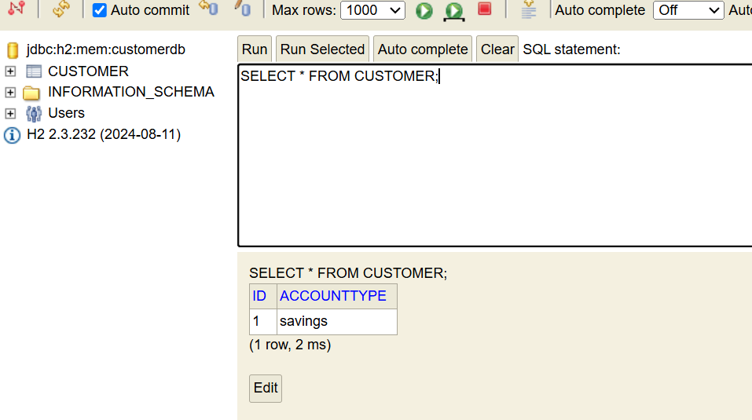

Task 6: What is the application.properties file?
application.properties is the main configuration file in Spring Boot. It is used to configure application settings such as database connection, server port, logging, security, and other Spring Boot properties.

Task 7:
Why use application properties… uses?
application.properties is used to store application configuration outside the Java code, making the application easier to configure and maintain.
Uses:
- Configure database connection.
- Change server port.
- Configure Hibernate/JPA.
- Enable H2 Console.
- Configure logging.
- Store application-specific properties.

Task 8:
What is application.yml?
application.yml is another configuration file in Spring Boot that uses YAML (YAML Ain't Markup Language) syntax instead of key-value pairs. It serves the same purpose as application.properties.

Task 9:
Why use/prefer to use application.yml instead of application.properties?
application.yml is preferred because it provides a cleaner, hierarchical structure for configuration.
Advantages:
- More readable.
- Less repetition.
- Better organization for complex configurations.
- Easier to manage nested properties.

Task 10:
What is Eureka Server?
Eureka Server is a Service Registry provided by Spring Cloud Netflix. It allows microservices to register themselves and discover other services dynamically without using hardcoded IP addresses.
Example:
- User Service registers with Eureka.
- Order Service registers with Eureka.
- Payment Service registers with Eureka.
All services can find each other through the Eureka Server.

Task 11:
Purpose of Eureka Server.
Answer:
The purpose of Eureka Server is to enable service registration and service discovery in a microservices architecture.
Uses:
- Registers all microservices.
- Helps services discover each other.
- Eliminates hardcoded IP addresses.
- Supports load balancing.
- Improves scalability and fault tolerance.

Home Task:

Task 1:
What do you know about Spring MVC framework?
Spring MVC (Model-View-Controller) is a web framework in the Spring Framework used to build Java-based web applications. It follows the MVC design pattern, which separates an application into Model, View, and Controller, making the application easier to develop, test, and maintain.
Task 2:
What is Dispatcher Servlet?
Dispatcher Servlet is the front controller of the Spring MVC framework. It receives every client request, processes it, forwards it to the appropriate controller, and returns the response to the client.
Task 3:
Can you explain Spring MVC with diagram
